Laboratory No. 1

DNA ISOLATION

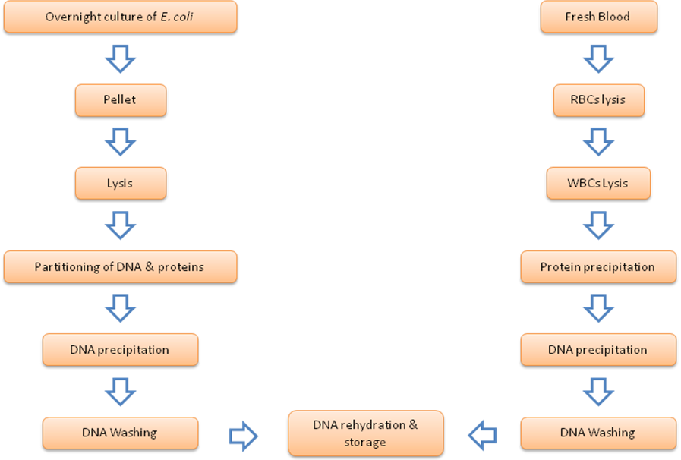
Work Flowchart

EXERCISE 1.1: DNA isolation from Escherichia coli

Materials & equipments:
1. Overnight culture of E. coli | 9. Micropipettes (100 – 1000 µl)
2. TE buffer | 10. Micropipettes (10 – 100 µl)
3. 10% (w/v) sodium dodecyl sulfate (SDS) | 11. Sterile blue tips (100 – 1000 µl)
4. 10 mg/ml proteinase K | 12. Sterile yellow tips (10 – 100 µl)
5. Phenol:chloroform:isoamyl alcohol (25:24:1) | 13. 1.5 ml tubes
6. Isopropanol | 14. Water bath
7. 70% ethanol | 15. Centrifuge (1.5 ml rotor)
8. 3M sodium acetate pH 5.2 | 16. Water bath
 | 17. Gloves
 | 18. Fume hood
 | 19. Racks (1.5 ml)
 | 20. Filter paper
Procedure:
- Grow E. coli culture overnight in broth.
- Transfer 1.5 ml to a 1.5-ml micro centrifuge tube and spin 2 min.
- Decant the supernatant.
- Resuspend the pellet in 460 μl TE buffer by repeated pipetting.
- Add 30 μl of 10% SDS and 10 μl of 20 mg/ml proteinase K, mix, and incubate 1 hr at 37 ° C.
- In the fume hood, add an equal volume of Phenol/chloroform/isoamyl alcohol and mix well but very gently to avoid shearing the DNA by inverting the tube until the phases are completely mixed. Caution: phenol causes severe burns.
- Carefully transfer the DNA/phenol mixture and spin at 12,000 RPM for 10 min.
- Transfer the upper aqueous phase to a new tube.
- Add 1/10 volume of sodium acetate. Mix.
- Add 0.6 volumes of isopropanol and mix gently until the DNA precipitates.
- Centrifuge at 12,000 RPM for 2 min.
- Decant the supernatant, add 1 ml of 70% ethanol, mix and centrifuge 12,000 RPM for 2 min.
- Aspirate the ethanol and air-dry the pellet (10–15 minutes)
- Rehydrate DNA in 100 μl TE buffer. Complete resuspension may take several days. Store DNA at 4 ° C short term, -20 or -80 ° C long term.
EXERCISE 1.2: DNA isolation from blood (Promega Kit)

Materials & equipments:
1 Fresh blood sample | 5. Micropipettes (100 – 1000 µl)
2. Isopropanol | 6. Sterile white tips (100 – 1000 µl)
3. 70% ethanol | 7. 1.5 ml tubes
4. Promega Wizard DNA purification kit | 8. Water bath
 | 9. Centrifuge (1.5 ml rotor)
 | 10. Water bath
 | 11. Gloves
 | 12. Fume hood
 | 13. Racks (1.5 ml)
 | 14. Vortex
 | 15. Filter paper

Procedure:
- Combine 900 µl of Cell Lysis Solution and 300 µl blood. Mix by inversion.
- Incubate for 10 minutes at room temperature.
- Centrifuge at 13,000–16,000 for 1 min.
- Discard supernatant. Vortex pellet.
- Add 400 µl Nuclei Lysis Solution and mix by inversion.
- Add 100 µl Protein Precipitation Solution; vortex for 20 seconds.
- Centrifuge at 13,000–16,000 for 3 min.
- Transfer supernatant to a new tube containing 600 µl isopropanol
- Centrifuge at 13,000–16,000 for 2 min.
- Discard supernatant. Add 70% ethanol (same volume as isopropanol).
- Centrifuge as in Step 9.
- Aspirate the ethanol and air-dry the pellet (10–15 minutes).
- Rehydrate the DNA in 100 µl of DNA Rehydration Solution for 1 hour at 65°C or overnight at 4°C.

REFERENCES:
- Anonymous (2016) Wizard® genomic DNA purification kit Instructions for use of products a1120, a1123, a1125 and a1620. Promega Corporation, USA.

- Maloy S. R. (1990) Experimental Techniques in Bacterial Genetics, Jones and Bartlet, USA.

